SIMATS ENGINEERING
ASSESSMENT TOOL 1: Experiments
COURSE NAME: COMPUTER VISION COURSE CODE:ITA0515 Slot

COURSE OUTCOME COVERED
CO3: Analyze and extract image features using detection and matching techniques for effective image representation and comparison. (BTL 4)
Assessment Tool Weightage: 40%

QUESTIONS:3 Total Marks 30 Duration :60 Minutes
Annexure A
Experiments

Code of Conduct:
I C Ruthika Reddy (Name / Reg No) certify that this submission is my original work and that I have adhered to the guidelines specified for this assessment.
I understand that any violation of academic integrity rules will result in disciplinary action.
Signature of the student: C Ruthika Reddy
Rubrics for Evaluation
Criteria | Weightage (%) | Level 4 (Exemplary) | Level 3 (Proficient) | Level 2 (Developing) | Level 1 (Beginning) | Marks(100)
Understanding of Concepts | 25 | Demonstrates thorough understanding and effectively integrates multiple concepts/technologies | Good understanding with proper integration of most concepts | Basic understanding; limited or partial integration | Poor understanding; unable to integrate concepts
Experimental Design | 30 | Well-planned, systematic implementation with optimal solution | Correct implementation with minor issues | Basic implementation with errors or inefficiencies | Incorrect or incomplete implementation
Use of Tools | 20 | Effective and advanced use of tools/technologies with proper configuration | Appropriate use of tools with correct execution | Limited or inconsistent use of tools | Incorrect or minimal use of tools
Analysis of Results | 15 | Insightful analysis with accurate interpretation and validation of results | Good analysis with reasonable interpretation | Basic analysis with limited insights | Poor or incorrect analysis of results
Documentation | 10 | Clear, well-structured documentation with diagrams, code, and results | Organized documentation with necessary details | Basic documentation with missing details | Poor or incomplete documentation

1. Harris Corner Detection Analysis

Aim
To perform Harris Corner Detection on images with different textures and patterns and analyze the distribution and significance of detected corners.

Procedure
- Read the input image.
- Convert the image into grayscale.
- Convert the grayscale image into floating-point format.
- Apply Harris Corner Detection.
- Use suitable values for:
  - Block size = 2
  - Aperture size = 3
  - Harris parameter k = 0.04
- Apply a threshold to identify strong corners.
- Mark the detected corners on the image.
- Display and analyze the result.

Python Code
import cv2
import numpy as np
import matplotlib.pyplot as plt

# Read image
img = cv2.imread("image.jpg")

# Convert to grayscale
gray = cv2.cvtColor(img, cv2.COLOR_BGR2GRAY)

# Convert to float32
gray = np.float32(gray)

# Harris corner detection
corners = cv2.cornerHarris(gray, 2, 3, 0.04)

# Dilate corner points
corners = cv2.dilate(corners, None)

# Mark strong corners
result = cv2.imread("image.jpg")
result[corners > 0.01 * corners.max()] = [0, 0, 255]

# Display
plt.imshow(cv2.cvtColor(result, cv2.COLOR_BGR2RGB))
plt.title("Harris Corner Detection")
plt.axis("off")
plt.show()

Input

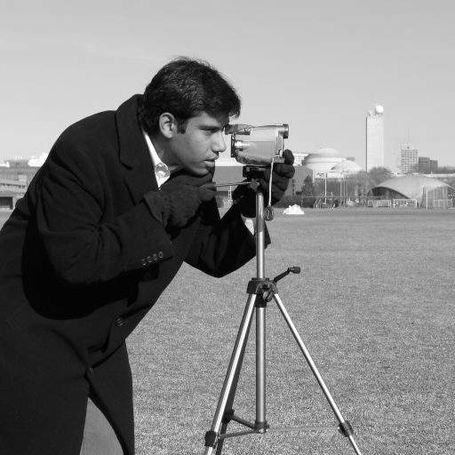

Output

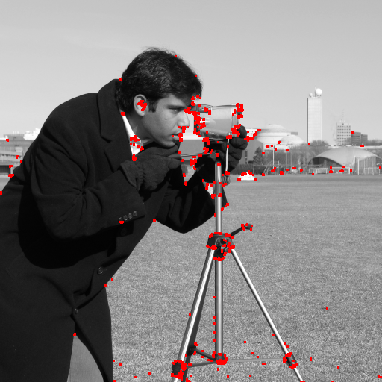

Result
Harris Corner Detection successfully detected significant corner points in images having different textures and patterns. The detected corners were concentrated around sharp and highly textured regions.

2. Effect of Noise on Corner Detection

Aim
To study the effect of different levels of noise on Harris Corner Detection and analyze how noise affects the accuracy of detected corners.

Procedure
- Read the original image.
- Convert it to grayscale.
- Apply Harris Corner Detection to the original image.
- Add Gaussian noise with different noise levels.
- Perform Harris Corner Detection on each noisy image.
- Compare the detected corners with the original image.
- Analyze the change in the number and location of corners.
- Apply Gaussian blur before detection as an improvement technique.

Python Code
import cv2
import numpy as np
import matplotlib.pyplot as plt

# Read image
img = cv2.imread("image.jpg")
gray = cv2.cvtColor(img, cv2.COLOR_BGR2GRAY)

# Harris function
def detect_corners(image):
gray_float = np.float32(image)
corners = cv2.cornerHarris(gray_float, 2, 3, 0.04)
result = cv2.cvtColor(image, cv2.COLOR_GRAY2BGR)
result[corners > 0.01 * corners.max()] = [0, 0, 255]
return result

# Original image
original_result = detect_corners(gray)

# Add Gaussian noise
noise = np.random.normal(0, 25, gray.shape)
noisy = gray.astype(np.float32) + noise
noisy = np.clip(noisy, 0, 255).astype(np.uint8)

# Detect corners in noisy image
noisy_result = detect_corners(noisy)

# Reduce noise using Gaussian blur
blurred = cv2.GaussianBlur(noisy, (5, 5), 0)

# Detect corners after noise reduction
improved_result = detect_corners(blurred)

# Display results
plt.figure(figsize=(12, 4))

plt.subplot(1, 3, 1)
plt.imshow(cv2.cvtColor(original_result, cv2.COLOR_BGR2RGB))
plt.title("Original")
plt.axis("off")

plt.subplot(1, 3, 2)
plt.imshow(cv2.cvtColor(noisy_result, cv2.COLOR_BGR2RGB))
plt.title("Noisy")
plt.axis("off")

plt.subplot(1, 3, 3)
plt.imshow(cv2.cvtColor(improved_result, cv2.COLOR_BGR2RGB))
plt.title("After Noise Reduction")
plt.axis("off")

plt.show()

Input

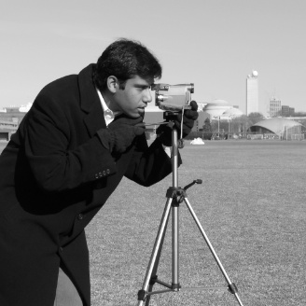

Output

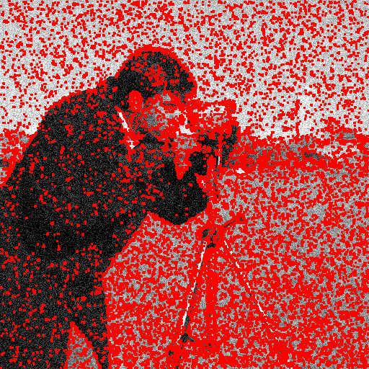

Result
The experiment showed that increasing noise decreases the reliability of Harris Corner Detection by producing false corner points. Applying noise reduction before corner detection improves the detection performance.

3. Hough Transform for Shape Detection

Aim
To detect lines or circles in an image using the Hough Transform and analyze the detected shapes under different image conditions.

Procedure
- Read the image.
- Convert it to grayscale.
- Apply Gaussian blur to reduce noise.
- Apply Canny edge detection.
- Apply Hough Line Transform.
- Obtain the detected line parameters.
- Draw the detected lines on the original image.
- Analyze the accuracy of the detected lines.

Python Code – Line Detection
import cv2
import numpy as np
import matplotlib.pyplot as plt

# Read image
img = cv2.imread("lines.jpg")

# Convert to grayscale
gray = cv2.cvtColor(img, cv2.COLOR_BGR2GRAY)

# Reduce noise
blur = cv2.GaussianBlur(gray, (5, 5), 0)

# Edge detection
edges = cv2.Canny(blur, 50, 150)

# Hough Line Transform
lines = cv2.HoughLines(edges, 1, np.pi / 180, 100)

# Draw detected lines
result = img.copy()

if lines is not None:
for line in lines:
rho, theta = line[0]

a = np.cos(theta)
b = np.sin(theta)

x0 = a * rho
y0 = b * rho

x1 = int(x0 + 1000 * (-b))
y1 = int(y0 + 1000 * a)

x2 = int(x0 - 1000 * (-b))
y2 = int(y0 - 1000 * a)

cv2.line(result, (x1, y1), (x2, y2), (0, 0, 255), 2)

# Display
plt.figure(figsize=(10, 4))

plt.subplot(1, 2, 1)
plt.imshow(cv2.cvtColor(img, cv2.COLOR_BGR2RGB))
plt.title("Original Image")
plt.axis("off")

plt.subplot(1, 2, 2)
plt.imshow(cv2.cvtColor(result, cv2.COLOR_BGR2RGB))
plt.title("Hough Line Detection")
plt.axis("off")

plt.show()

Input

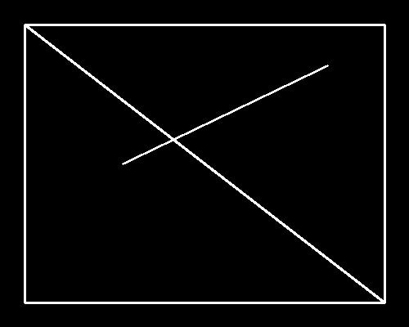

Output

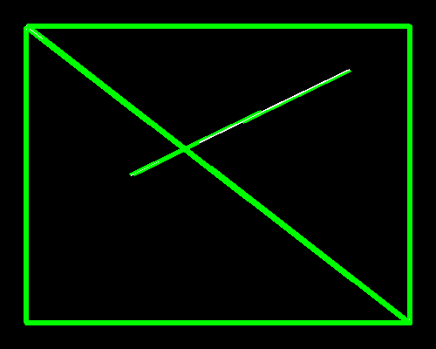

Result
The Hough Transform successfully detected prominent straight lines in the image. The accuracy of detection depended on image quality, edge strength, noise level, and the selected threshold.

